**Cucumber Framework**

To build the framework I have used cucumber and selenium (java) with the ItelliJ IDE.

**Structure**

The folder structure under the Java directory:

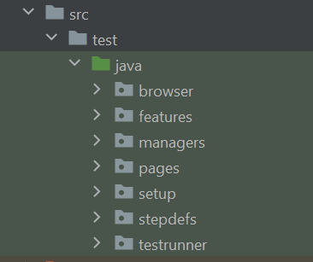

Browser

The browser package contains all the classes and enums needed to control the browser. The ConfigFileReader class, reads the config file.

Features

The feature package holds all the feature files. The feature files hold the automated gherkin testcases.

Managers

The managers package holds all the manager classes.

The FileReaderManager initializes the ConfigFileReader.

The PagObjectManager initializes all the pages.

The WebDriverManager holds all the methods to configure the driver.

Pages

The pages package holds all the classes which contain methods and elements for each page. (Page Object Model)

Setup

The setup package holds the setup class which contains the @Before and @After tags the run the code before and after each scenario.

The @Before code gets the driver.

The @After code deletes the data created to reset it for the next test and closes and quits the browser. (Teardown)

StepDefs

The stepdefs package holds all the step definitions (Code used to connect to the feature file steps)

TestRunner

The testrunner package holds the testrunner class. This uses junit to run the tests.

**The configuration.properties File**

The configuration.properties file holds the config of the browser, url and timeouts etc…



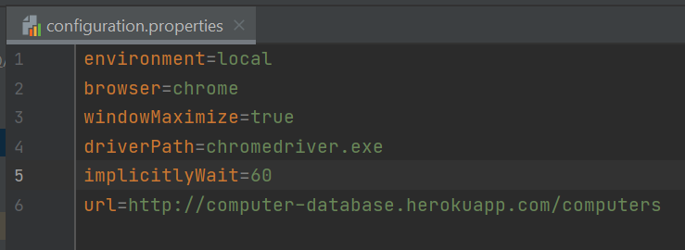

**The documents folder**

The documents folder holds a text file with all the automated and not automated testcases also the framework document.

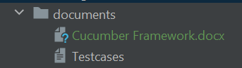

**Repository**

The code can be found on github in repository: https://github.com/dstride1980/BackBase.git